Llanrug, Arete Outdoor Centre
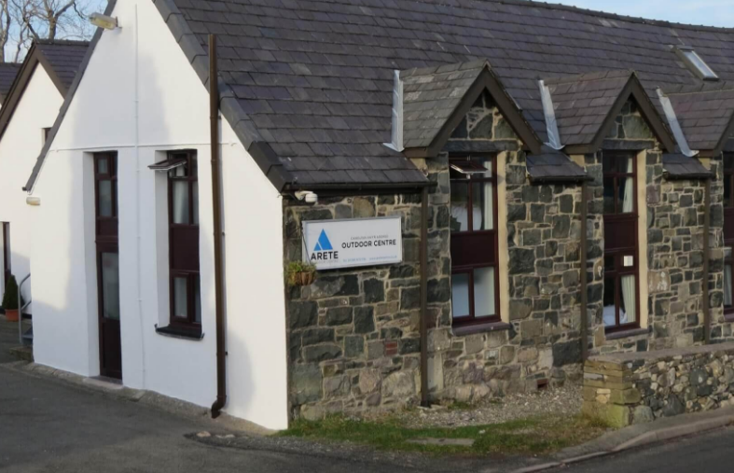
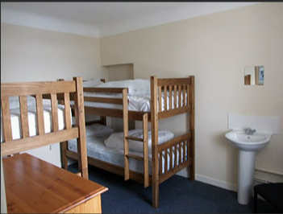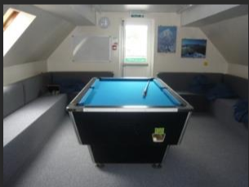
In Key Stage 3 and 4, pupils get the opportunity to go to Llanrug, Wales to the Arete Outdoor Centre for 4 nights.
AIM - for pupils to build on their independence, teamwork and risk-taking skills.
Pupils wake up each morning and make their own packed lunch for the day ahead, as once we have left the accommodation in the morning, we do not return until dinner time. At breakfast, pupils serve their peers and clear-up and help wash dishes. After breakfast, in groups, pupils complete the morning chores (wiping tables/ floors, vacuuming, putting tables away etc)

Pupils then hear about the activities they are going on that day in their groups. Example activities include gorge walking, canoeing, bodyboarding, caving, orienteering, beach exploring and rock climbing. Activities are tailored to the groups and are accessible for all pupils who wish to attend. The activities aim to challenge pupils, whilst they are having fun.

After the days' activities, pupils come back to the Centre for dinnertime. Like breakfast, there are jobs which need to be done before and after dinner, which all pupils participate in.

After dinner, pupils then get ready for their evening activity. Again, these activities are tailored to the group but have included in the past: mountain walk, assault course, campfire and songs, movie night (if the weather is poor).

It is an incredible 5 days, 4 nights away (Monday-Friday). Our young people (and staff!) have come back and expressed that it's been 'the best week of our lives!'

