KEEPING SAFE ONLINE- Advice for Parents and Carers
Online Safety- Background
Online technology provides new opportunities for young people’s learning and growth
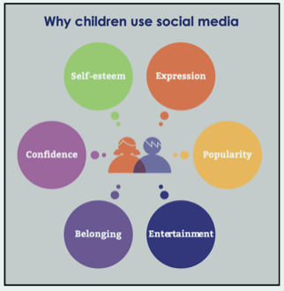
However, it can also expose them to new types of risks including: cyber bullying; emotional abuse; grooming; sexting; sexual abuse; sexual exploitation; county lines
Here are some key statements produced by the Royal Society of Public Health:
- 91% of 16-24 year olds use the internet for social networking
- Social media has been described as more addictive than cigarettes and alcohol
- Rates of anxiety and depression in young people have risen 70% in the past 25 years
- Social media use is linked with increased rates of anxiety, depression and poor sleep
- Cyber bullying is a growing problem with 7 in 10 young people saying they have experienced it
Sadly, pupils at Hazel Oak school are no different. In fact, they are having to deal with added complications around communication, social skills and emotional regulation.
Here are some common issues student experience at Hazel Oak:
- Online communication is misinterpreted or miscommunicated, causing arguments and offence.
- Threatening messages
- Students joining messaging groups without being invited
- Inappropriate images being sent or requested
- Relationship issues impacting on mental health
- Students offloading worries on to each other, causing the recipient to feel worried themselves.
- Lack of sleep as a result of using devices before bed time or late into the night
- Self harming as a result of bullying
This video is example of how social media can impact on mental health.
Online Safety- School Support
Hazel Oak school are able to support students through the curriculum. However, it is not possible to monitor or police what is happening at home (which is when students use social media). It is therefore imperative that issues are dealt with and preventative measures in put into practice in at home.
Hazel Oak are however able to educate students through:
- Relationships and Sex Education Lessons
- Community Police visits
- Social communication programme such as Talkabout or Language Links
- Philosophy for Children topics
- Discussions through assemblies
- Restorative Practice
- Risk Reduction Plans
- Access to a Learning Disability Nurse if intervention meets criteria
- Providing social opportunities with adult supervision with the intent to scaffold social interaction
- Zones of Regulation activities
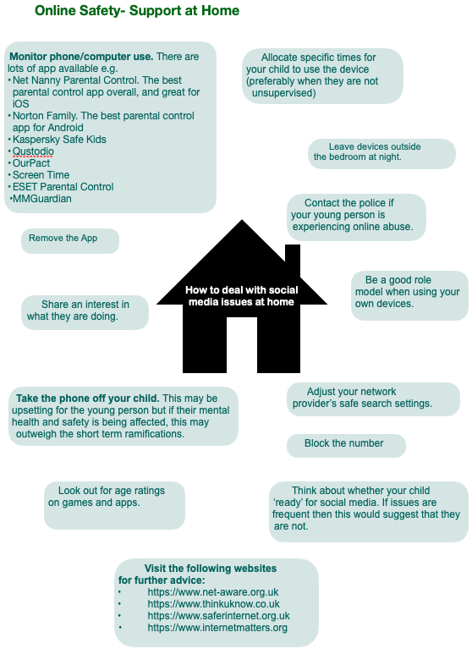
- Address:
- Hazel Oak School
- Hazeloak Road
- Shirley
- Solihull
- West Midlands
- B90 2AZ
- Telephone:
- 0121 744 4162
- Email:
- office@hazel-oak.solihull.sch.uk
Hazel Oak School ©2023

